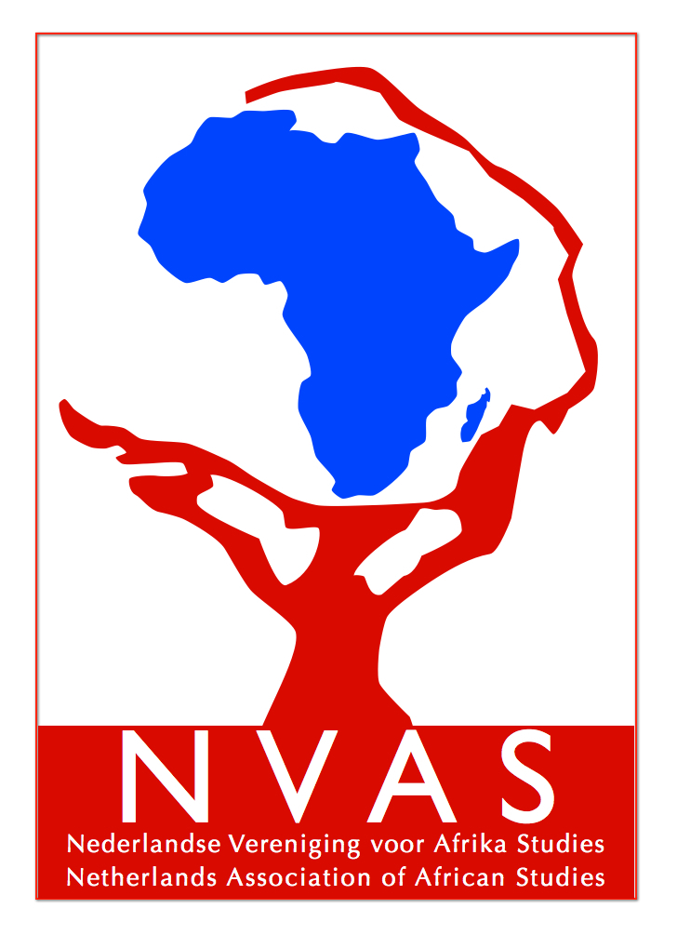

Registration form NVAS Sport in Africa Day
NVAS Africa Day
15th of October 2016
Utrecht University, School of Governance
Bijlhouwerstraat 6
3511 ZC Utrecht
Registration per e-mail before 5th of October 2016
Please fill out this form and send it to Marieke van Winden winden@ascleiden.nl
(One form per person)

Name: ………………………………………………………………………….…………
Address: …… …………………………………………………………………………………………….
E-mail:……………………. ……………………………….
Tel: …………………………………………………………………………….………
Organisation: ……………………………………………………………………...............................

I register for the NVAS Sport in Africa and pay the following amount (including lunch and drinks):

- € 15 , because I am an NVAS or ABV member)
- € 15 euro, because I am a student (course………………………………………………..…, University: …………………, student no:………………………………….(this includes a one-year free membership)
- € 25, because none of the above is applicable (this includes a one-year membership)
The fee is transferrable to NVAS, Leiden, bankaccount no. NL08INGB0007819046 before 5th October reference “Sport in Africa” and the name(s) of the person(s) registered.

Thank you very much for registering. We are looking forward to meeting you on the 15th of October!

The organising committee NVAS Sport in Africa Day

